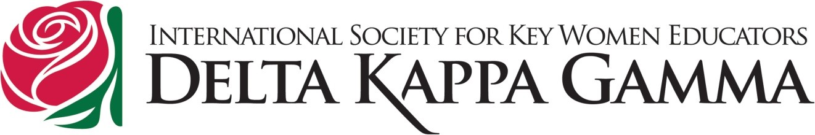
BEAR PROJECT
MEDIA USAGE PERMISSION FORM
By signing below, I am granting permission to Delta Kappa Gamma (DKG) for me/my child(ren)/ family to be filmed, videotaped, audio taped, photographed, by any means, and am granting full use of name, likeness, voice, and words without compensation. I understand my/my child(ren)/family’s name and image might be used on DKG websites/blogs (international, state, and/or local), in written and audio media such as local/state newspapers; DKG newsletters, publications, and presentations, on local radio spots, or used in other media.

Name(s) (Printed):______________________________________________________________________
_____________________________________________________________________________________
____________________________________________________________________________________
_____________________________________________________________________________________
_____________________________________________________________________________________

Signature (Or signature of
Parent/Guardian if under 18):___________________________________________________________

Date:_______________________________________________________________________

Please return this permission slip and refer any questions regarding it to the local DKG Chapter President or BEAR Project Committee Chair.

